SECTION 3

2026
CERAMICS

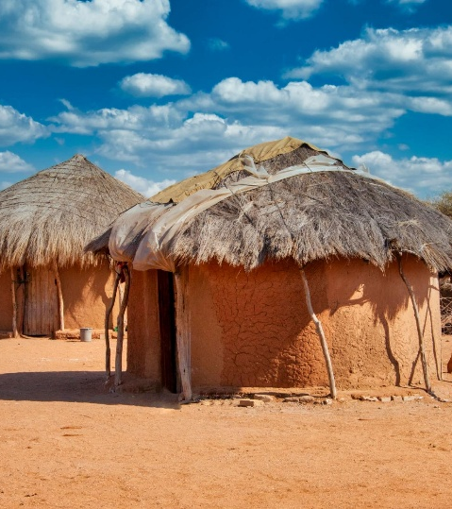
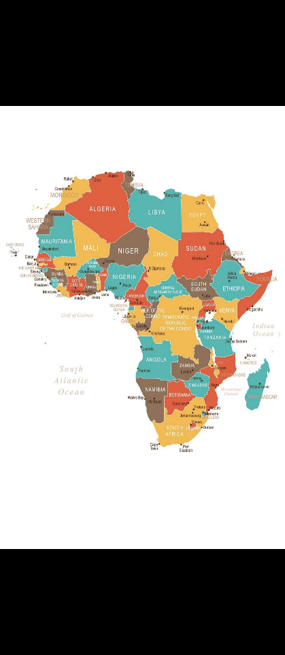
. ..

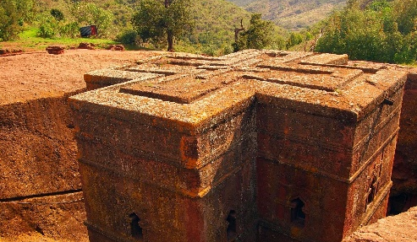

Theme: Out of Africa – 54 Countries to choose from

SHOW DATES
Friday 3rd July - Opening Night
Saturday 4th - Sunday 5th July
Monday 6th July - Public Holiday

2026 TOWNSVILLE SHOW CERAMICS SCHEDULE

ENTRIES CLOSE: MONDAY 8TH JUNE 2026
DELIVERY OF PIECES: SUNDAY 28TH JUNE 2026

SECTION 3 - CERAMICS

HOBBY CERAMICS

JUDGE: TBA

ENTRY FEE: $3.00 per piece entered
$2.00 per piece/Seniors
$2.00 per piece/Assisted Person
$2.00 Admin. Fee (Per Entry Form)

PRIZES: 1st $10.00 Cash or Voucher
2nd $5.00 Cash or Voucher
Ribbon for First & Second & Third in each class
Class Champions $50 - Cash or Voucher
Grand Champion $50 - Cash or Voucher
Reserve Champion $50 - Cash or Voucher
Best of Theme $15 - Cash or Voucher
Best Special Feature $15 - Cash or Voucher

ENTRIES CLOSE: 4.00 pm MONDAY 8TH JUNE 2026.

DELIVER TO: Townsville Showgrounds Office
72 Ingham Rd, West End.
(07) 4771 4964

THEME OF THE 2026 SHOW:
“Out of Africa”
See Classes & Definitions for details

SPECIAL FEATURE OF THE 2026 SHOW:
“Anything from Greenware Adaption”
See Classes & Definitions for details

We hope you will enter this year’s exhibition and enjoy the Competition.

GOODS AND SERVICES TAX


ABN: 90 324 554 361

CONDITIONS OF ENTRY – CERAMICS

Note: All pieces entered MUST be the entrant’s own creation. If more than 50% of the entry has been copied from another source eg. magazine/book etc., the magazine/book must be submitted with the entry to allow for correct judging.

Delivery of Pieces- Ceramic pieces to be delivered to the pavilion under the main grandstand between 2pm and 3pm on Sunday 28th June 2026. You are able to drive into the main grandstand to deliver your items, however, please ensure you drive slowly & use caution whilst moving throughout the showgrounds.
Note: Entries can be left at the Show Office prior to this time. If you do so, please ensure you have attached your name, class and category to the piece, or attach a copy of your entry form to any piece you leave there.
All exhibitors or their representatives must sign their pieces in and out at the time of delivery and collection.

All entries must stay on exhibit for the duration of the Show.

Entries must be collected between 9.30 am and 11 am on Tuesday 7th July 2026.
If these times are not suitable to the entrant- Please ring the day before to make arrangements with the Ceramic Chief Steward – Robyn on 0498698392

You may enter as many pieces per category as you wish.
Only work completed between the 01/07/2025 & 02/06/2026 can be submitted for judging.
All wrapping for ceramics, boxes etc. MUST be removed by exhibitor, as no storage is available or allowed on site.

SPECIAL FEATURE and THEME: The Theme and Special Feature will change each year. Entries then will be judged in either Theme or Special Feature as nominated by entrant. Entries will be judged in their Original Nomination First, before they will be Judged in Theme or Special Fea

FOR SALE
Any person who sells any piece of work from the exhibition will not be penalized by having to enter the Professional class next year.

Your initials and date eg. JC or *** & 03/26 must be carved underneath your piece at the greenware stage. This applies to all classes. Failure to do so will incur a penalty of loss of maximum points.

Please DO NOT put your initials and date on the front of your show entry.
It is a Show Entry- You will incur Loss of maximum of points.
Entries with loose lids, parts, etc. must be securely taped. Plaques and plates must have suitable stands, which are to be labelled with your name, or return of stands cannot be guaranteed. No props etc. to be displayed with entries. It is recommended that fragile pieces be mounted in protective cases.

Do not felt bottoms, except for weighted pieces, eg. chess pieces, bookends. Only 6 pieces of a chess set to be displayed. Lamps, tiles and mosaic pieces secured to a background may be exempt also.
Add-ons must be adhered to a piece at greenware or at glaze firing stages. The only exceptions can be music boxes, carousels, soap pumps & water features where discreet gluing must not be detectable.

Do not dry foot pieces, they will be disqualified as will pieces that are creacked or chipped. The inside of all pieces should be sealed either with Glaze or Acrylics. Dust under rims and stilt marks not removed from any piece will incur a loss of maximum points.

Decorative only – If the decoration of a piece means it can’t be used for its original function eg. plates, cups, dishes etc., it must be clearly incised on the base as Decorative Only so it can be judged correctly.

A Novice’s or a junior’s entry form MUST BE SIGNED by a Teacher or Parent. NOTE: A junior’s date of birth has to be entered also.
All care will be taken with handling of entries, but no responsibility can be taken by the Show Association, Judges or Stewards.

As in any exhibition – Judges decision is final.

ENTRY FEES:
The TPA&IA is required to pay GST on all entry fees received. All entry fees stated in the schedule include GST. All exhibitors must pay the GST inclusive entry fees whether they are registered for GST purposes or not.
Exhibitors who are registered for GST purposes may be able to claim a credit for GST paid. We recommend you check with your Financial Advisor or the Australian Taxation Office. To assist with any claim for credit we will forward at the exhibitor’s request a Tax Invoice/Receipt for the total entry fees received including GST.

PRIZE MONEY:
Prize money stated in the schedule excludes GST. GST will be added to the prize money for exhibitors who are registered for GST purposes and provide our Association with a Recipient Created Tax Invoice. Townsville Pastoral Agricultural & Industrial Association will not issue tax invoices in respect of prizes. Some prizes may be in the form of vouchers or prizes from Sponsors. (Cash will not be given out instead of prizes.) Please inform the Townsville Pastoral Agricultural & Industrial Association that you are registered when nominating and notify TPA & IA again, if you cease to be registered.

PRESENTATIONS & PRIZES:
If exhibitors are unable to collect their prize money on the nominated day, arrangement can be made to have prize money directly deposited into their nominated bank account or have a cheque forwarded to their address. A form for your preferred payment option will be available from the Administration Office.
Prize money will be available for collection from the main office between Monday 13th July and Friday 24TH July 2026. If an entrant is unable to collect their prize money during this period, they must contact the Townsville Show Office on (07) 4771 4964 to arrange a Cheque to be mailed to their address. Any money not collected by Friday 24TH July 2026 may be forfeited if alternative arrangements are not made.
There will be No Presentation Night as stated by the T.P.A. and I. Association.

SPONSORSHIP:
The Association is required to pay GST on sponsorship monies received.
Sponsorship monies stated in the front of the schedule includes GST paid.
Sponsors who are registered for GST purposes may be able to claim a credit for GST paid. We recommend sponsors check with their Financial Advisor or the Australian Taxation Office. We will issue a Tax Invoice to all sponsors.

Please contact the Chief Stewards before the 8th of June 2026, where possible, if you would like to Sponsor the 2026 Townsville Ceramic Exhibition. The TPA&IA appreciates any support local businesses or individuals can offer the section.

Ceramics Chief Steward - Robyn Cundy - 0498 698 392

FREE PASSES WILL BE ISSUED TO STEWARDS & VOLUNTEERS BUT NOT TO GENERAL EXHIBITORS.

Please contact your Local Studio or the Chief Stewards if you would like to be a volunteer at the coming 2025 Townsville Hobby Ceramic Exhibition and or the Townsville Pottery Exhibition.

Ceramics Chief Steward – Robyn Cundy - 0498 698 392

Special Feature – Anything from Greenware Adaption – quite a few to choose from.

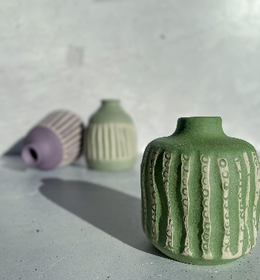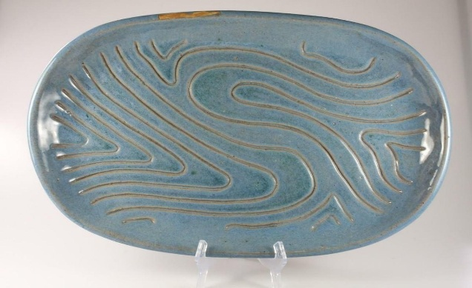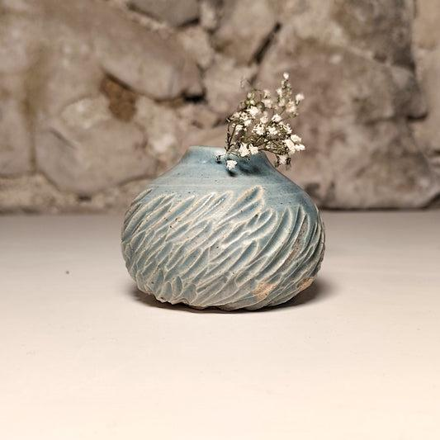

CLASSES & DEFINITIONS:

Classes for the Townsville Show Ceramics Section are: Professional, Open, Intermediate, Novice, Senior Citizen, Junior, Assisted. Theme of Show & Special Feature of Show, will come from Classes entered. The definitions of each are outlined below for entrant to read over & ensure they are entering in the correct Class. Note: In all Classes – where there is only one entrant – No Championship will be given for that section. There must be entering per class at least two persons.

PROFESSIONAL:
Any persons who now owns, operates, or conducts a ceramic studio or business, or has in the past, or who teaches or sells ceramics commercially for profit or operates under a business name, or is a market stall holder or regularly sells for profit or sells on Social Media. Professional class entrants are not eligible for Grand Champion of Show – BUT are eligible for Reserve Champion. NOTE: Any person who has won Grand Champion 3 times in the past will now be classed as a Professional.

OPEN:
Any person who enters the competition that is not a Novice, Senior Citizen, Junior, Assisted Person or Professional. NOTE: When an ‘Open’ entrant wins a minimum of 3 Grand Championships – they will then move to Professional Class.

SENIOR CITIZENS:
Any person 65yrs of age and over, who does not now, and has not in the past owned, operated, conducted, or taught in a Ceramics studio, or business, and has not at any time been involved in any phase or form of a ceramic business commercially for profit. NOTE: Entry into this classification is optional, but once a Senior Citizen that is then your Class to enter. As in other Classes – if you win a Grand Champion 3 times – you will then be a Professional Class.

JUNIOR & ASSISTED PERSON:
Children up to and including 15 yrs of age as at 7th of June, 2026. Date of birth to be supplied. Children over this age will go to open class, unless, they are a Novice learning ceramics. When over the age of junior and not a Novice the entrant will move to open class. Assisted persons who have a health condition, impairment or disability that makes it more difficult for them to complete a Ceramic piece, will now be included in this section. NOTE: When a Junior/Assisted Person entrant wins a minimum of 3 Grand Championships – they will then move to Professional Class.

NOVICE:
Any person that was a Novice for 2024 Ceramic Exhibition, will now be classed as Novice for 2 years of learning. 2024 and 2025 are the beginning of the extension. A certified teacher MUST sign the Exhibitors entry form. A first show entry does not qualify as an entrant as a Novice. Once they have been a Novice for 2 years, they will go to open class.

THEME OF SHOW: Out of Africa – 54 Countries to Choose from – your Choice.
Theme interpretation will cover all categories. If you wish to have any piece judged in the Theme category, as well as in the one you have nominated, write. Y in the Theme column on your entry form.

SPECIAL FEATURE OF SHOW: Anything from Greenware Adaption – lots to choose frome – Your Choice. The special feature interpretation will cover all categories. If you wish to have any piece judged in the Special Feature Category, as well as the one you have nominated, write ‘Ý’ in the column of your entry form.
Please note: Your piece will be judged in either Theme or Special Feature as nominated by you – Not In Both.
CATEGORIES:

1 - GREENWARE ADAPTATION
Altering the original appearance of a greenware piece by:
- CUT OUTS areas of clay removed – usually done at the Leather Hard Stage of Greenware.

- CLAY LIFTING: Lifting edges of a design.

- CARVING: Incising and beveling of line to raise a 3-dimensional pattern.

- CLAY CARVE (Water Etch): Sealing design and washing away background.

- CHEMICALLY TEXTURED: the use of acid products to wear away a background or create a textured surface

- DECORATION: the addition of decoration such as: - dipped fabric flowers, cloth and stripping (lace draping). Shaping and forming of flowers and/or patterns. This includes all forms of sprigging or adding hand-built form.

- FABRIC DRAPING: Fabric dipped in slip and joined to a piece of Leather Hard Greenware.

- GREENWARE COMBINATION: Using 2 or more pieces of Greenware to make a new piece.

- TEXTURING: Incising the background to form a pattern, e.g. wood grain.

- MULTI-TECHNIQUE: At least 3 techniques/mediums as detailed in categories 1 – 4 combined onto one piece. NOTE: Clear Glaze and Coloured Glaze totally covered by an Overglaze, is one technique only and not a multi-technique. Example is – Piece that has Greenware Adaptation (A to I), Glaze and Acrylics on it.

2 - UNDERGLAZE
- HAND PAINTED DESIGN: Brushwork design – Line work, decorative painting and painting of designs. Where Brushwork is apparent (not blocked in.)

- DETAIL IN MOLD: Applied colour to a design formed in the mold.

- MAJOLICA: Underglaze decoration applied over unfired non-moving glaze before firing.

- SGRAFFITO: Scratching a design through colour with a tool.

- AIRBRUSHING: Design or technique to be done by Air Gun.

- ANTIQUING: Applying colour and wiping back from raised surface.

- UNDERGLAZE DECORATION: Solid Colour or design – brushwork (floral, animals, geometric, etc.)

3 - GLAZE
- GLAZE COMBINATION: Multi-glazes applied over each other - usually with modifying glaze between them.

- MAJOLICA: Using non-fried, non-moving glazes as a design over unfired non-moving glaze before firing.

- GLAZE IN DESIGN: Glazes used as a Design.

- GLAZE INLAY: Laying glazes into certain areas of a pattern.

- SGRAFFITO: Cutting a design through a glaze.

- CONTROLLED GLAZE: Glazes buttered to each other in specific areas.

4 – Acrylics – Non-fired Colour
- FREE BRUSH DESIGN: Where brush stoke is apparent.

- ANTIQUING & OPAQUE: Applied colour to raised areas formed in the mold. Translucent colour applied then wiped off raised areas.

- METALLICS: Metallic like materials in paste, powder or liquid form.

- CHALKS/PASTELS: Rouging on colour using fine chalk powder.

- DRY BRUSHING: Brushing colour onto raised areas after most of colour is wiped from brush.

- APPLIED TEXTURE – Adding sand, grog or paper to stain media, then applying to bisque piece.

- AIRBRUSHING: Design or technique to be done by air gun.

5 - MIXED MEDIA
Any Ceramic Piece where other non-ceramic mediums have been used – 60% has to be Ceramic and 40 % other Non-Ceramic medium.
- e.g... Alcohol Inks, Resin, Gold Leaf, Beading, Glass etc., on your Ceramic Piece. Date and initial your work as normal at the Greenware stage. 40% of Non-Ceramic Mediums.

Also, Handcraft is part of Mixed Media where you add Clock Fittings, Music Boxes etc.

6 – Hand Building with Earthenware Clay only-
All Entries to be Totally Hand Built by Entrant with Eathware Clay Only. LOW Fire Clay

All entries will be eligible for 1st, 2nd, 3rd, Class Champion and Best Hand Built Piece in Show.

*** THEME – 2026 ***
Out of Africa – 54 Countries to Choose from - Your Choice.

Any piece may be used. Show how you can bring this year’s Theme to life

*** SPECIAL FEATURE - 2026 ***
Anything from Greenware Adaption – Plenty to choose from – Your Choice

Any piece may be used. Show everyone what you can do – Very Exciting to see the work you do.
No Miscellaneous in any Categories- Pieces may be entered in Mixed Media where other non-ceramic mediums have been used- examples- clock movements, music boxes, Alcohol Inks, Resin, Gold Leaf, Beading, Glass, Carousel Fittings, etc…

All Cards/Ribbons and Pieces will remain on Display for the Length of the Exhibition for all to see.

Judge’s Decision is Final.

Entry Forms must be submitted along with Entry Fees to the Townsville Show Office by 4pm MONDAY 8th JUNE 2026.
The Townsville Show Office is located just inside the gate located at
72 Ingham Rd (on the corner of Ingham Service Rd & Parkes St, West End) Should you need to contact the office please call (07) 4771 4964.

Pieces must be delivered to the pavilion under the main grandstand at the Townsville Showgrounds between 2pm & 3pm on Sunday, 28th June 2026.



Record of your entries for the 2026 Exhibition
(This is for Entrants to keep & to note what items they have entered for judging)
Piece Name/Description | Class Entered

Thank you for your entries and your support in 2026!

If you are able to help us by volunteering to assist with spending some time on the Ceramics Stand during the ‘Show’ - Please Contact Robyn on 0498 698 392.

The Townsville Pastoral, Agricultural & Industrial Association wishes to express its appreciation to all persons and companies, who by their generous support and donations have helped make the 2026 Townsville Show possible.

PLEASE READ:

Reasons for Disqualifications or Loss of Major Points:-
Cracks – Chips – Dry Footing – Breaks (e.g. Legs) – Hollow Handles in Food Items – Rough Textures on bases of entries – Pieces Glued back onto an entry when they have blown off in the kiln – Seminar Pieces – Bottoms of entries covered in felt or cork – Pieces must be able to be fully Judges i.e NO Pieces to be secured to a background – Pieces entered in previous shows anywhere – Using texture pens to cover mistakes on entries – Name of Entrant on front of entry.

